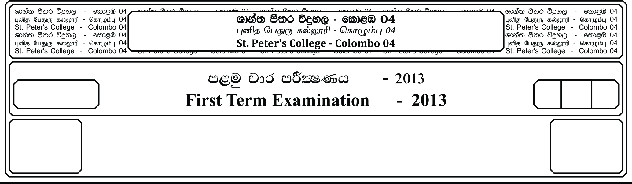

12 fY%aKsh

GRADE 12

E

meh

Hours

I

**m<uq jdr mÍCIKh - 2021**

**First Term Examination - 2021**

Ôj úoHdj - »

**BIOLOGY – I**

* **Instructions**

**Answer all the questions.**

**Select the correct or most appropriate answer.**

(01). Which one of the following is corrct regarding charcteristics of living organism ?

(i). Energy carrier molecules form during metabolism.

(ii). Irritability is the ability to respond to stimuli from both internal and external environments.

(iii). Irreversible changes in dry mass occurs during growth.

(iv). Sunken stomata in xerophytes is an example for peculiarity of physiology.

(v). Ability of organsim to change physiologically, morphologically structurally over time is evolution.

(02). Water is a vital inorganic molecule, It is important due to the which one of the following reason.

(i). Ability to moderate temperature

(ii). Expansion upon freezing

(iii). Provides a biological medium for all organisms

(iv). Being versatile solvent for most of the solules

(v ). Posses cohesive behaviour.

(03). Which one of the following is correct regarding carbohydrates?

(i). All hexsoes contain an aldehyde group

(ii). All sugars are reducing sugars

(iii). Glyceraldehyde has a sweet taste

(iv). Galacturonic acid is the monomer of chitin

(v). Inulin stores glucose as energy stores in Dahlia tubers.

(04). Select the correct statment regarding lipids

(i). All lipids contain a glycerol molecule

(ii). H:O ration in lipids is equal to 2:1 ration

(iii). Three ester bonds found in fat

(iv). Staturated fats lack double bond

(v). Consumption of excess trans saturated fats contribute to atheroscierosis

(05). Given below are some compounds found in living matter

(a). Glycogen (b). Hemicellulose (c). Cellulose (d). Amylose

Which of the above compound / s is / are branched, and made out of Glucose?

(i). a,c (ii). b only (iii). a,d only

(iv). b,c only (v). a only

(06). Which one of the following bond found in both secondary and quaternary structure of protein which make their specific shapes?

(i). Peptide bonds (ii). Hydrogen Bonds

(iii). Vander Waals interactions (iv). Ionic bonds

(v). Covalent bonds

(07). Select incorrect combinationg regarding functions of proteins?

(i). Keratin - Protection (ii). Haemoglobin - Transport

(iii). Myosin - Contraction (iv). Actin - Support

(v). Amylaze - Catalyze

(8) Piece of DNA consist of 500 complete turns. A : G ration in the DNa is 2:3

The number of thymine bases in the DNA piece is

(i). 1000 (ii). 3000 (iii). 4000 (iv). 1500 (v). 2000

(9) Select incorrect statment regarding nuclic acids of eukaryotic cells.

(i). All nucleic acids synthesized in the nucleus.

(ii). All nucleic acids help to ensure the survival of an organism.

(iii). All types of nucleic acids posses hydrogen bonds.

(iv). All nucleic acids posses monosaccharides.

(v). All nucleic acids posses phospho disaster bond.

(10). Select the incorrect combination regarding functions of nucleotides

(i). Co- enzyme – ATP (ii). Electron Carrier - NADP+

(iii). Co- enzyme - NAD+ (iv). Reducing agent - NADP+

(v). Energy Currency- ATP

(11). Select the incorrect statement regarding microscope

(i). Magnification is ratio of an object’s image size to its actual size

(ii). Resolution power is directly propotional to the wave length.

(iii). Magnification is depend on resolution power

(iv). Specimens, stained with heavy metals prior to observation under electron microscope

(v). Light microscope use to observe non-living specimens.

* A is a mixture of compounds. It gives following observaions with different reagents.

Febilings Millon Ethanol Biuret

Solution Reagent + cool water Reagent

Brick Red White No Colour Purple

Precipitate precipitate Change Colour

(12). Which one of the following is correct regarding A ?

(i). It contains glucose, fat, protein

(ii). It contains reducing sugar and non reducing sugar

(iii). It contains protein, lipid, reducing sugar

(iv). It contains Protein, reducing sugat

(v). It contains Protein, glucose

(13). Select incorrect statement regarding double membrane bound organelles in eukariyotic cells

(i). Consist of both DNA and RNA

(ii). Contain 70 S ribosomes

(iii). Membranes are perforated

(iv). Energy consuming process takes place

(v). Matrix contain energy carrier molecules

(14). Which one of the follwing is not a function of smooth ER?

(i). Synthesizes glycoprotein (ii). Metabolism of Carbohydrates

(iii). Detoxification (iv). Syntheize oils

(v). Stores Ca2+ ions.

(15). Which one of the follwoing is incorrect regarding prokoryotic cell?

(i). DNA combines with proteins (ii). Consist of subcellular component

(iii). Cell wall consists of proteins (iv). Flagella has (9 + 0) structure

(v). Consist of photosynthetic pigments.

**Part II**

**Answer all questions on this paper itself. Each question carries 10 marks**

1. (A).

1). There are 25 essential elements for humans. Write 4 most common elements out of them.

_______________________________________________________________________

_______________________________________________________________________

2). Write 4 major properties of water.

_______________________________________________________________________

_______________________________________________________________________

_______________________________________________________________________

_______________________________________________________________________

3). Explain one of it briefly.

_______________________________________________________________________

_______________________________________________________________________

_______________________________________________________________________

_______________________________________________________________________

4). Monosaccharides is a type of carbohydrate write it’s general formulae.

_______________________________________________________________________

5). Write one example for each of the following.

A). Tetrose - ______________________________________________________

B). Triose - ______________________________________________________

C). Pentoses - ______________________________________________________

6). Write one common structural charteristic between glucose and galactose.

_______________________________________________________________________

B).

1). What is a disaccharide?

_______________________________________________________________________

_______________________________________________________________________

_______________________________________________________________________

2). Explain experimental steps to distinguish sucrose from maltose.

_______________________________________________________________________

_______________________________________________________________________

_______________________________________________________________________

_______________________________________________________________________

_______________________________________________________________________

_______________________________________________________________________

_______________________________________________________________________

3). Write the bond type found between monomers of following compounds.

A). Sucrose - ______________________________________________________

B). Amylose - ______________________________________________________

C). Maltose - ______________________________________________________

4). A). What is a lipid?

_________________________________________________________________

_________________________________________________________________

_________________________________________________________________

B). Explain how a fatty acid and molecule and phospholipid molecule differ from each other. (Functionally)

_________________________________________________________________

_________________________________________________________________

_________________________________________________________________

C). Explain how is this special feature of phospholipid molecule is important in making cell membrane.

_________________________________________________________________

_________________________________________________________________

_________________________________________________________________

_________________________________________________________________

5). Write 2 other biologically important lipids.

_______________________________________________________________________

C).

i). Draw the structure of glycin

ii). Write the intramolecular bond types found in following proteins

A). Keratin

_________________________________________________________________

B). Collagen

_________________________________________________________________

C). Albumin

_________________________________________________________________

iii). Write components of repeating unit of DNA

_______________________________________________________________________

_______________________________________________________________________

iv). Give suitable examples for the following

A). Most common type of RNA - ___________________________________

B). RNA type synthesized by nucleolus - ___________________________________

C). RNA type having hydrogen bonds - ___________________________________

v). Write one functional similarty between DNA and m-RNA

_______________________________________________________________________

_______________________________________________________________________

vi). Write one exampke for each following. (using nucleotides)

A). Act as coenzyme - ______________________________

B). Act as electron carrier - ______________________________

C). Oxidizing agent during cellular respiration - ______________________________

2.

A).

i). Define the term magnification of microscopes.

_______________________________________________________________________

_______________________________________________________________________

ii). Write the resolution power of followings

A). Human eye - ________________________________________________

B). Electron Microscope - ________________________________________________

C). Light Microscope - ________________________________________________

iii). Write the contribution made by the the following scientists for the cell theory.

A). Robert Hooke

_________________________________________________________________

_________________________________________________________________

B). Anton Van Leeu wenhook

_________________________________________________________________

_________________________________________________________________

iv). Write 4 basic features shared by all cells.

_______________________________________________________________________

_______________________________________________________________________

_______________________________________________________________________

_______________________________________________________________________

_______________________________________________________________________

_______________________________________________________________________

_______________________________________________________________________

_______________________________________________________________________

v). What is a cell orgonelle?

_______________________________________________________________________

_______________________________________________________________________

vi). Write 4 major parts of nucelus?

_______________________________________________________________________

_______________________________________________________________________

B).

i). What is the endoplasmic reticulam

_______________________________________________________________________

_______________________________________________________________________

_______________________________________________________________________

ii). State 02 other single membrance bound organelles

1. _______________________________ 2. _______________________________

iii). Write the cell organelles which perform following functions

A). Transport residue material out of cell

_________________________________________________________________

B). Converts fatty acids into sugar

_________________________________________________________________

iv).

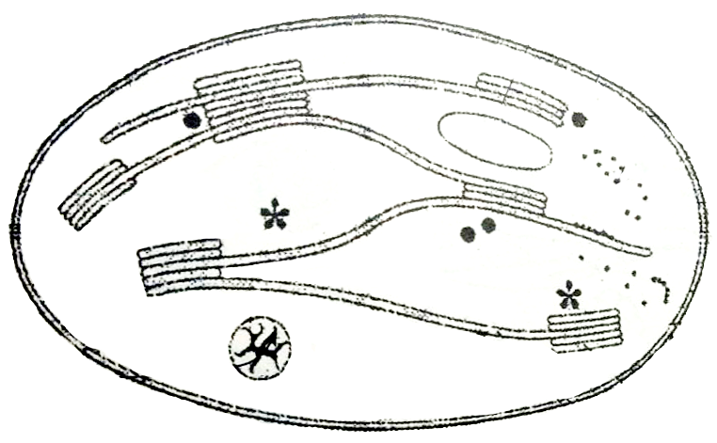

**P**

**S**

**R**

**Q**

**}**

a). Label (P-S)

P - R -

Q - S -

b). Write one important compound found on Q.

_______________________________________________________________________

c). Write 03 different components found in matrix of the above organelle.

_______________________________________________________________________

_______________________________________________________________________

_______________________________________________________________________

C)

i). What are the 2 stages of cellular respiration takes place in mitochondria?

1. _________________________________________________________________

2. _________________________________________________________________

ii). What is cytoskeleton?

_______________________________________________________________________

_______________________________________________________________________

iii). Write 03 componenets of cytoskeleton and building blocks of them.

_______________________________________________________________________

_______________________________________________________________________

_______________________________________________________________________

iv). Write 02 function of cytoskeleton.

_______________________________________________________________________

_______________________________________________________________________

v). What is the (9 +2) structure of cilia?

_______________________________________________________________________

_______________________________________________________________________

vi). How centriole structure differ from flagella structure?

_______________________________________________________________________

_______________________________________________________________________

vii). Write 02 functions of central vacuole.

_______________________________________________________________________

_______________________________________________________________________

viii). A). What are the componenets of ECM?

_________________________________________________________________

_________________________________________________________________

B). Write 03 functions of ECM.

_________________________________________________________________

_________________________________________________________________

_________________________________________________________________

**Essay Questions**

**Answer all questions**

1). A). Explain Fluid mosasic model of plasma membrance

B). Explain functions of plasma membrane

2). Write short notes on followings

A). Prokarryotic cell structure

B). Eukaryotic cell wall

C). Cell juntions